**VIDEO GAMES SALES QLIK REPORT**

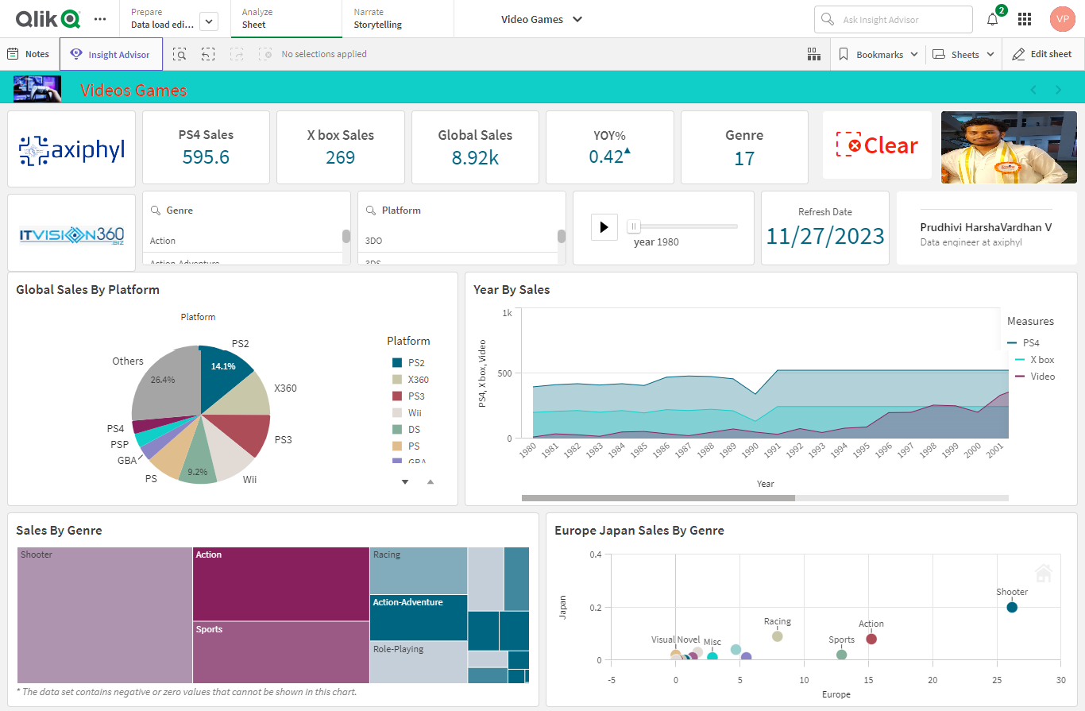

The main objective of this report is to analyse video game sales that contain genre and platform and where the sales of the game on which platform had the highest sales. An understanding of the video game sales process and data is required to read the report.

**Project Overview**

Data Source

Problem Statement

Key Performance Indicators (KPIs) and Data Dictionary

Executive Summary and Problems Encountered

Key Insights -Positive

Key Insights -Negative

Suggestions

Data Source

My Qlik Report consists of the following steps:

**Data collection:** Dataset has been collected from Kaggle.

**Data Preparation:** The dataset has been cleaned and processed for the analysis.

**Exploratory Data Analysis:** Data has been analysed to understand the sales of the Video Games Sales in Europe, Japan, North America by different Genre.

**Data visualization:** we’ll Visualize the data to identify the Video Games Sales.

**Simple Recommendation System:** Developed a visualization of sales in the Video Game Sales.

 Key Performance Indicators (KPIs) and Data Dictionary

Key Performance Indicators

**PS4 Sales:** Sum(ps4)

**X box Sales:** Sum (Global)

**Global Sales:** Sum ([Global _sales])

**Genre:** count (Genre)

**Data Dictionary**

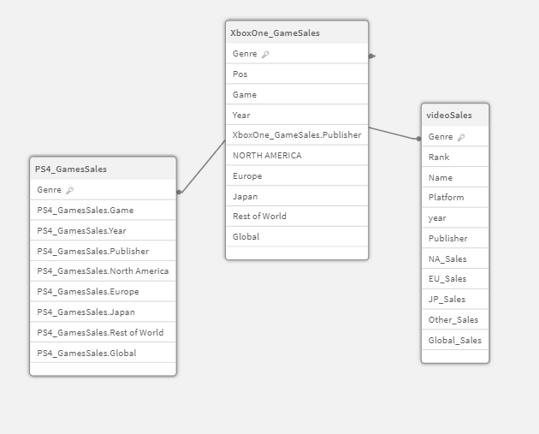

Executive Summary and Problems Encountered

The dataset contains several columns representing various attributes of the Video Games Sales includes Name, Year, Genre, Platform, Publisher, Europe Sales, Japan Sales, North America Sales, Global Sales and other tables PS4, X box contains same fields. Examining Sales and seeing any patterns or trends in sales might be part of this goal.

**Problems Encountered**

1.Choosing the correct data set was a challenge.

2.Selecting the proper KPI for the project was the other challenge. I have googled and gone through previous projects to come up with the right KPIs for the project.

3.Selecting the right KPI was the other problem occurred. MoM% was initially attempted but it does not show the desired output so there was a need to change it to YoY%.

Positive Insights:

|  |  |
| --- | --- |
| Insight | Positive |
| KPI | YOY% |
| Good or Bad | Good |
| Responsible Dim | Genre/Year |
| More Effect Occurred | The Sales Year over Year Increased |
| Where It is Occurred | Europe, Japan, North America |
| When the problem occurred | 1980 to 2017 |

Key Insights – Negatives

|  |  |
| --- | --- |
| Insight | Negative |
| KPI | GPM YOY% |
| Good or Bad | Bad |
| Responsible Dim | Genre/Year |
| Where It is Occurred | Europe, Japan, North America |
| When the problem occurred | 1980 to 2017 |

Suggestions

1. Quality Gameplay and Graphics:

Ensure that your game offers high-quality gameplay and graphics. A visually appealing and immersive experience can attract and retain players.

1. Multiplayer and Social Features:

Implement multiplayer features to allow players to interact with each other. Social features, such as leader boards and in-game chat, can enhance the gaming experience.

1. Optimize Performance:

Ensure that your game performs well on different devices. Optimize for various screen sizes and resolutions to provide a smooth experience.